Th you

We give you five easy ways to order:

- Online via our website
- Fill out the order form and
- Fax it
- Post it
- Email it
- Call us

7 Butlers Mead, Millend, Blakeney, GL15 4EH

Phone/Fax (01594)516 490
orders@booksatpress.co.uk
www.booksatpress.co.uk

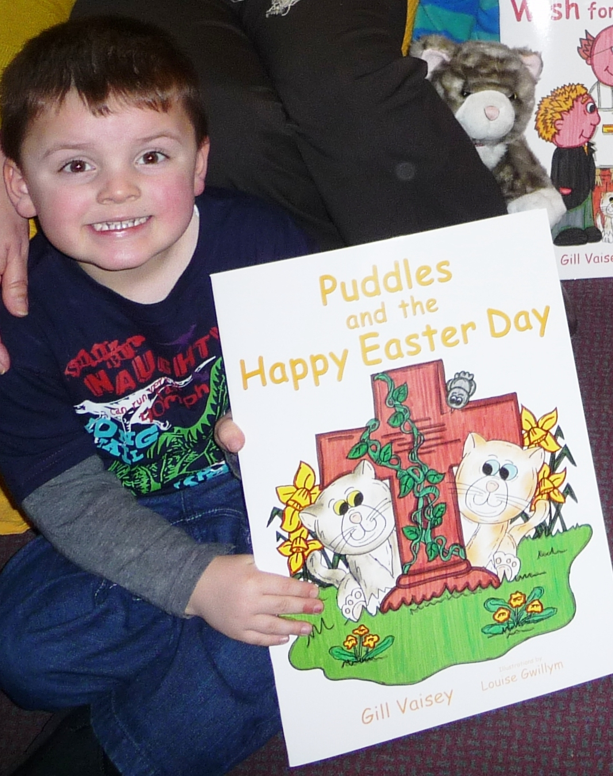

Resource | Qty | Price | Total
Puddles and Freddie series:
Puddles and the Christening Splash Big book |  | £14.99
Puddles and the Christening Splash Standard size special edition |  | £ 7.99
Puddles and the Christmas Play Big book |  | £14.99
A Wet and Windy Harvest for Puddles Big book |  | £14.99
Puddles Lends A Paw Big book |  | £14.99
A Wedding Day Wish for Puddles Big book |  | £14.99
Puddles and the Happy Easter Day Big book |  | £14.99
NEW: Puddles and the St Francis Service Big book |  | £14.99
Puddles Soft Toy (30cm) Soft Toy Cat |  | £14.99
Arthur Soft Toy (30cm) Soft Toy Cat |  | £14.99
Kittens Set 4 x Soft toy kittens (for Easter, Splash & St Francis stories) |  | £29.99
NEW: Kittens set 2 x Sot toy kittens ( for St Francis story) |  | £ 9.99
The Reverend Freddie Fisher (43cm standing vicar, 1alb, 4 sets different coloured stoles and chasubles, FREE teachers’ notes) |  | £39.99
PLAN+3 x 7 (detailed planning and 3 pupil activities sent by email) |  | £20.93
Set of all Puddles resources as above:  with FREE PLAN+3 x 7 (save £33.80) |  | £210
School / Organisation: ……………………………………………………….Order No……........
Name: …………………………………………………………………………………….Phone:………………….……
Address:………………………………………………………………………………………………………………..………………………............................................................................................
Post Code:………………..Email:…....………………………….…………………………………………
Where did you hear about us? ………………………………………………………………………………………………………..
Traditional Muslim Stories about the natural world:
The Tiny Ants Big book and cross-curricular resource pack |  | £32.99
The Tiny Ants Standard book |  | £ 7.99
Seven New Kittens Big Book and cross-curricular resource pack |  | £32.99
Seven New Kittens Standard book |  | £ 7.99
The Baby Birds Standard size book and CD Rom |  | £12.99
The Baby Birds Puppets Mother hand puppet and 5 baby finger  puppets with nest storage bag |  | £20.00
PLAN+3 x 3 (detailed planning and 3 pupil activities sent by email) |  | £8.97
Set of Muslim resources as above  with FREE PLAN+3 x 3 (save £28.92) |  | £95

Belonging and Believing: (hardback non-fiction, age guide 4 +)
My Bahá’í Family |  | £14.99
My Buddhist Family |  | £14.99
My Christian Family |  | £14.99
My Hindu Family |  | £14.99
My Humanist Family |  | £14.99
My Jewish Family |  | £14.99
My Muslim Family |  | £14.99
My Sikh Family |  | £14.99
Set of all Belonging and Believing as above (save £9.92). |  | £110

COMPLETE SET OF ALL OUR RESOURCES as above  Total overall saving £77.64! |  | £410

Individual PLAN+3 (please specify for which books required) |  | £2.99

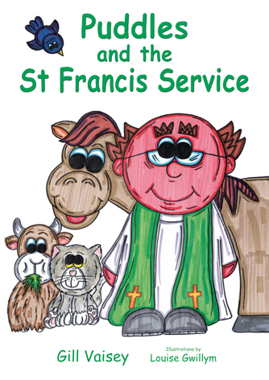
SPECIAL OFFER
Buy the latest big book with Puddles cat and receive the PLAN+3* and
2 kittens FREE! (saving £12.98)
*(teachers’ planning and 3 pupil activities)
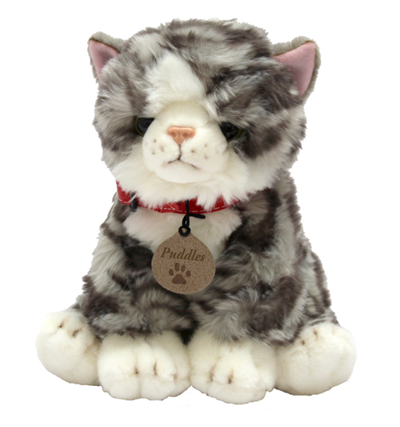

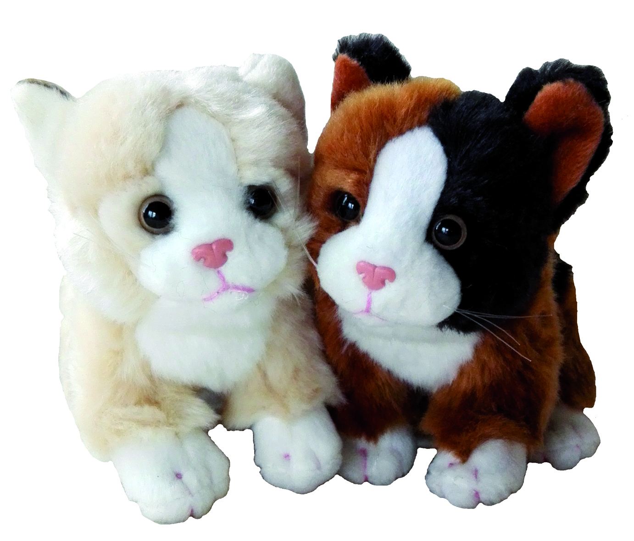

£29.98 + £3 VAT

Festivals in Different Cultures: (Hardback, non-fiction, age guide 3 +)
Festivals in Different Cultures: (Hardback, non-fiction, age guide 3 +)

Exploring Clothes People Wear (age guide 3 +)
The Swirling Hijaab (fiction, age guide 3 +) (paperback) |  | £8.99
Hats of Faith (boardbook) |  | £7.99
The Clothes We Wear My World Series – see below (paperback) |  | £6.99
Hats Off! (paperback) |  | £6.99
Set of 4 books as above – save £1.96 |  | £29.00

Cultural Education:
My World Your World: (Paperback, non-fiction, age guide 6 +)
The Food We Eat |  | £6.99
Celebrations and Special Days |  | £6.99
A Place To Call Home |  | £6.99
Time For School |  | £6.99
The Clothes We Wear |  | £6.99
Everybody Needs Water |  | £6.99
Time To Play |  | £6.99
How We Get Around |  | £6.99
Set of 8 as above: buy 7 get 1 FREE! (Save £6.99) |  | £48.93

Stories Set In Different Countries: (Paperback, non-fiction, age guide 4 +)
Farmer Falgu Goes Kite Flying |  | £6.99
Farmer Falgu Goes to the Kumbh Mela |  | £6.99
Fatou Fetch The Water |  | £7.99

Wellbeing and Mental Health:
JJ’s Journey Into The Wise Wood |  | £6.99

Total Order Cost | £
P&P: The most economical cost of P&P will be added to your invoice.  (To enclose a cheque, please check P&P by phone or see website). | £
Sub Total | £
VAT (20% on P&P, cats, kittens, vicar, and puppets.) | £
Cheque enclosed made payable to Books@Press/ Gill Vaisey

Please invoice (schools, LAs, Church Dioceses and other official organisations only)

School / Organisation: …………………………………………………………………………….…….
Order No……………….………………………
Name: ...........................................................................................................................
Position: ……………………………………………………………………………………………………….
Phone:………………….……………………….
Address:…………………………………………………………………………………………………………
……..………………………..........................................................................................
Post Code:…………………………..
Email:…………………………………………………………………………………………………
Where did you hear about us?
………………………………………………………………………………………………………..

May 2021


Transform Your RE with Belonging and Believing
This wonderful new series explores the lived experience of a five-year old child, their family and community.
The series reflects 8 different religions and worldviews. .
Resource | Qty | Price | Total
Belonging and Believing: (Hardback books)
My Bahá’í Family |  | £14.99
My Buddhist Family |  | £14.99
My Christian Family |  | £14.99
My Hindu Family |  | £14.99
My Humanist Family |  | £14.99
My Jewish Family |  | £14.99
My Muslim Family |  | £14.99
My Sikh Family |  | £14.99
Set of all Belonging and Believing as above (save £9.92). Plus P&P at £8.50 (for up to 4 sets – the most economical P&P cost will be applied to orders greater than 4 sets) |  | £110
www.booksatpress.co.uk


7 Butlers Mead, Millend,
Blakeney, GL15 4EH

Phone/Fax (01594)516 490
orders@booksatpress.co.uk
www.booksatpress.co.uk

We give you five easy ways to order:

- Online via our website
- Fill out the order form and
- Fax it
- Post it
- Email it
- Call us

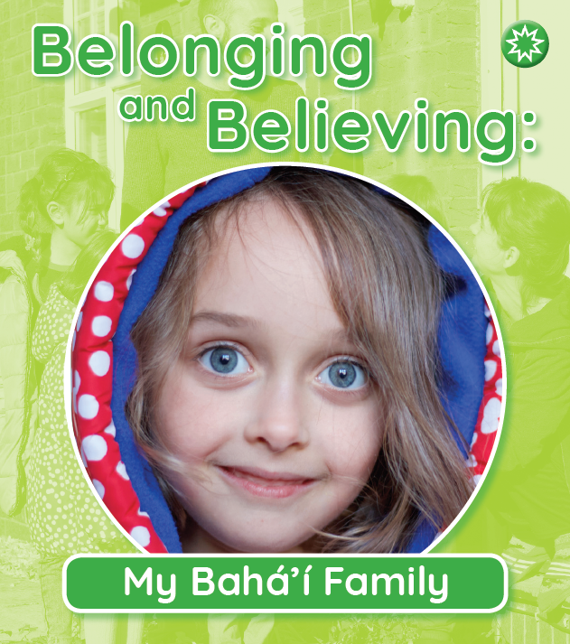
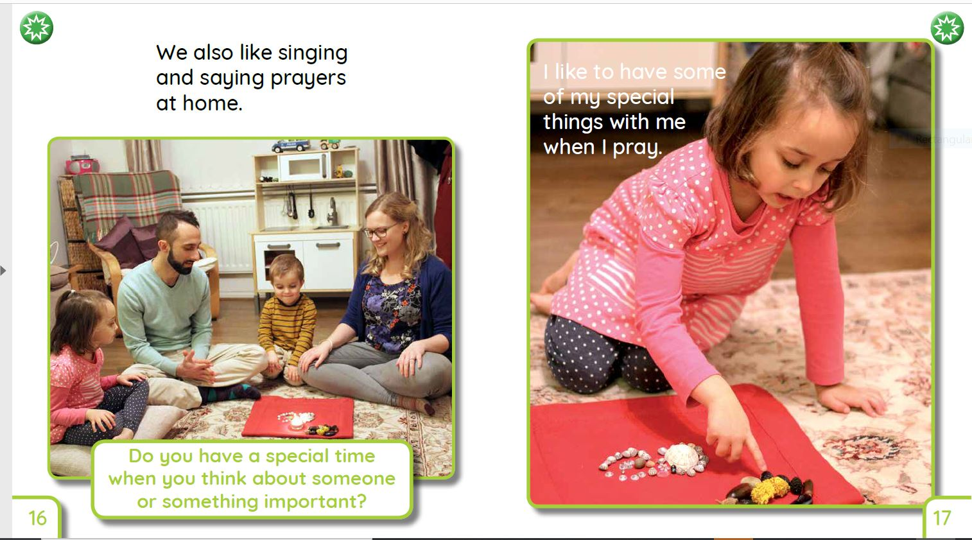

School / Organisation: ……………………………….……………………………….
Order No……………….…………………………………………………….………………
Name: …………………………………………………………………………………..…….
Position: ……………………………………………………………………………………..
Phone:………………….……………………………………………………….…………….
Address:………………………………………………………………………………………
………………………………………………..………………………..………………………..
………………………………………………..………………………..………………………..
Post Code:…………………………………………………………………………………..
Email:……………………………………………………………………………………………
Where did you hear about us? ……………………………………………………………………………………………………

………………………………………………………………………………….………………..

Postage and Packing Charges
From January 2022
Goods are despatched by Royal Mail post or Courier at the cheapest possible rate and P&P is calculated according to the weight of your order.
For orders made by post, email, fax or telephone requesting an invoice, we will add the appropriate P&P when we process your order.
Standard delivery: (standard delivery will be used unless otherwise requested – delivery usually within 5 – 10 working days)
Orders | P & P cost  + VAT
Standard size books  Costs if your order only includes up to 3 standard size paperback books :  1 Standard size book  2 Standard size books  3 Standard size books | £2.95  £3.50  £4.50
Costs for all other products:  1 item  2 – 4 items  5 items or more | £2.95 / £3.95  £5.95  £8.50

If ordering and making payment online, our automated system will calculate the P&P charges and add them to your account. The charts below can be used as a guide however there may be instances where charges vary due to the automated system.

Express delivery: (please request express delivery if your order is urgent - delivery usually within 1 – 3 working days)
Orders | P & P cost  + VAT
Standard size books  Costs if your order only includes up to 3 standard size books:  1 Standard size book  2 Standard size books  3 Standard size books | £3.50  £4.50  £5.50
Costs for all other products:  1 item  2 – 4 items  5 items or more | £5.95  £8.95  £10.50

